

1. My target keyword for this page is: SILUS GAMING WORLD

2. Add your target keyword to your page’s URL. For example: *mywebsite.com/my-keyword or mywebsite.com/my-keyword-guide*

**Why It’s Important:** Google uses the terms in your URL to understand what your page is all about.

bauska.org/Silus

3. Use your keyword once at the top of your page (ideally in the first 50-100 words).

**Why It’s Important:** Search engines put more weight on terms that appear in prominent places on your page (like at the top).

4. Use your keyword in your page’s title tag.

**Why It’s Important:** From a Google SEO point of view, your title tag is the most important place to include your keyword.

5. Use your keyword in an H1 and H2 Subheader.

**Why It’s Important:** This emphasizes to Google that your page is focused on that keyword and topic. H tags aren’t a huge deal for rankings. But every little bit helps.

6. Use keyword-rich image filenames and alt text.

**Why It’s Important:** Google uses images to understand the content of your page. And descriptive file names and alt text helps them understand what your page is all about.

7. Add internal links to other pages on your site. I recommend including at least 5 internal links per page.

**Why It’s Important:** Internal links can help Google find, crawl and index more pages on your site (and help them rank higher in the search results).

8. Add external links to other helpful websites and resources.

**Why It’s Important:** External linking to related pages helps Google figure out your page's topic. So I recommend adding lots of external links to pages that will help your users learn more about something that you cover on your page.

9. Use synonyms and related terms.

**Why It’s Important:** In other words: include variations of your target keyword on your page. For example, if your main keyword is “kettlebell workout”, use variations like “kettlebell exercises” and “easy kettlebell movements”.

10. Write an enticing meta description.

**Why It’s Important:**  Although using keywords in your meta description isn’t a ranking factor anymore, [organic click through rate](https://backlinko.com/hub/seo/organic-ctr) is. And when Google searchers see a compelling meta description in the organic search results, they’re more likely to click on your site.

11. Make your site work with mobile devices.

**Why It’s Important:** In other words, your site should be mobile-optimized for Google users and search engine crawlers. [Google’s index is now “mobile-first”](https://developers.google.com/search/mobile-sites/mobile-first-indexing), which makes mobile usability an absolute most for SEO.

12. Use structured data.

**Why It’s Important:** Structured data (Schema) can help your site feature “[Rich Snippets](https://backlinko.com/hub/seo/snippets)” in the search results.

13. Match search intent. Double check that your page is a 1:1 match for search intent. The best way to do that? Check out Google’s first page for that keyword. If they’re all a specific type of page (like a list post or ecommerce product page), you want your page to be in-line with what’s already ranking.

**Why It’s Important:** If your page doesn’t satisfy [search intent](https://backlinko.com/hub/seo/search-intent), your page most likely will not rank for that keyword (even if you have lots of backlinks). It’s that important.

14. Decrease bounce rate. In other words: make your content “sticky” so that Google users stay on your page...and don’t bounce back to the search results.

**Why It’s Important:** Bounce rate probably isn’t a direct Google ranking factor. But it might be. Especially if that bounce leads to “[pogosticking](https://backlinko.com/hub/seo/pogosticking)”.

15. Write a title tag that’s keyword optimized and engineered for clicks. The best way to do this is to think of what you would want to click on if you were searching for your target keyword.

**Why It’s Important:** Like I mentioned back in item #10 from this list, a high CTR can boost your rankings. And your title tag [is a BIG factor in what people use to decide what to click on](https://backlinko.com/google-ctr-stats).

That’s it for this on-page SEO template. I hope you enjoyed it! Remember, you can find 20+ other marketing templates [here](https://backlinko.com/templates).

And if you want a more in-depth look and further explanation of everything in this template, check out my [Definitive Guide to On-Page SEO](https://backlinko.com/on-page-seo).

Brian Dean

Founder, Backlinko.com

How YouTube’s search algorithm works

Wait, what is YouTube SEO? As I’ve mentioned above, SEO stands for search engine optimization, which is precisely what you need to do to ensure your videos rank high up in YouTube’s search results.

The process is pretty straightforward and very similar to the kind of SEO you’d apply to a web page or blog post to get in to appear in Google search results.

“YouTube search strives to surface the most relevant results according to keyword searches,” [the platform says](https://support.google.com/youtube/answer/141805#zippy=%2Chow-are-videos-ranked-on-the-home-page%2Chow-are-videos-ranked-in-search). Two YouTube ranking factors impact whether (and how high up) your video appears on the search engine results page (SERPs).

1. How well the title, description, and video content match the viewer’s search.
2. What videos drive the most engagement for a search.

Since search engine optimization primarily deals with the process in point #1 above, I’ll zero in on that in this article. For guidance on #2, I’d suggest checking out our guides to getting [more subscribers on YouTube](https://buffer.com/resources/get-more-subscribers-on-youtube/) and creating [YouTube thumbnails](https://buffer.com/resources/youtube-thumbnails/).

YouTube notes that search results “are not a list of the most-viewed videos for a given search.” So, a well-optimized video is still in with a chance, no matter how new you are to YouTube.

SEO and Marketing Consultant [Jo Juliana Turnbull](https://www.linkedin.com/in/j-turnbull/) has experienced this first-hand in both her work as a marketer and the YouTube series she's worked on — Tea Time SEO, [Turn Digi](https://www.youtube.com/channel/UC5pFy7sF-xpqSvtfmrvs4Bg), and more recently, [SEO Office Hours](https://www.youtube.com/@good_signals), which she co-hosts and is run by Mike Chidzey.  
  
Thanks to the power of optimization, SEO Office Hours is already earning thousands of views per video. “We have not done any paid media to promote the shows, and SEO Office Hours has some videos with up to 5,500 views.” Not bad for a five-month-old show.

[Kelly Ayres](https://www.linkedin.com/in/kla1/), Director of SEO at Jordan Digital Marketing, agrees. “Unlike Google Search, where historical traffic and authority are somewhat necessary for ranking highly, engagement and early traffic can establish a YouTube channel fairly quickly,” she told us.

“If videos are audience-focused, branded appropriately, and optimized effectively, and creators are consistent with their [video marketing strategy](https://buffer.com/library/video-marketing-strategies/), a new channel can appear at the top of the YouTube search results.”

There are several steps to optimizing your videos for search, all of which fall into two main categories. I’m going to break this process down into:

1. Keyword research
2. Optimizing your YouTube videos

💡

Search is just one of YouTube’s feed algorithms, and it’s worth getting to grips with the video ranking factors, like engagement and watch time, that influence these other areas. Check out our [guide to the YouTube algorithm](https://buffer.com/resources/youtube-algorithm/) for more.

## YouTube keyword research

Keywords are words or phrases that people use to search for content. Their importance on YouTube can’t be overstated — these are some of the primary signals the YouTube search algorithm looks at to figure out how to give users exactly what they want.

If your video metadata (title, description, and more) doesn’t contain relevant keywords, it won’t appear in the search results.

A word to the wise (again): don’t leave your keyword research until after you’ve scripted, filmed, or edited your video. It’s best to **do your keyword research for any**[**YouTube content ideas**](https://buffer.com/resources/grow-youtube-shorts/)**you have before you make the video**. It’ll help you cover all the areas YouTube users want to learn about on any given topic. Bonus: it might even help spark new video ideas for your channel!

## 1. Brainstorm your keywords

Think like your target audience to find the best keywords for your video. Ask yourself:

* “What problems does my video solve?” or “What questions does my video answer?”
* “If I had this problem or question, what would I type into the search bar to help me find the answer?”

People search for different things in different ways, so jot down any related keywords that accurately describe your content.

## 2. See what’s already ranking on YouTube

From there, head over to YouTube, type your keyword into the search box, and assess the results.

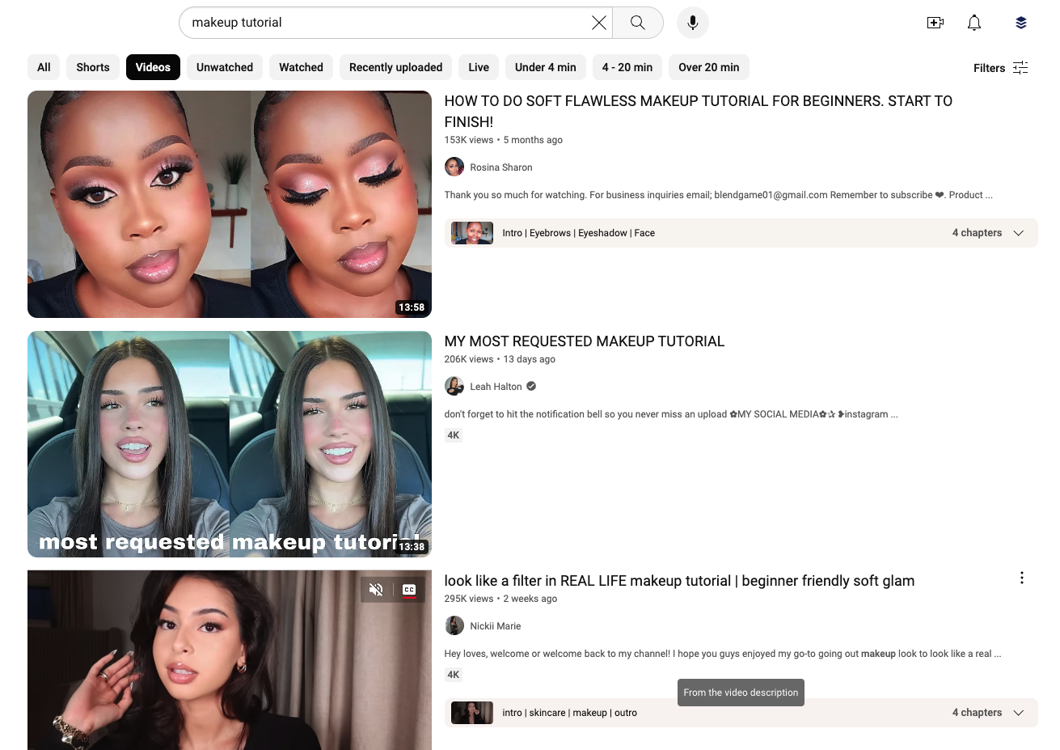

Are the videos in the list in line with what you want to create? If yes, you’re on the right track! “You’re getting some very valuable insight here,” [says Gillian Perkins](https://www.youtube.com/watch?v=TjyqaRRLx_g&ab_channel=GillianPerkins), a YouTuber with over 700k subscribers and millions of views.

“You’re learning what the algorithm has decided people want when they search for those words. So you want to make sure your content is in alignment with that.”

Are the results not quite in line with what you hoped to create? Try some variations on the theme until you find videos like yours.

## 3. Refine your keyword list with SEO tools

There are a host of keyword research tools that can help you (we have a comprehensive list of 20+ [free SEO tools](https://buffer.com/library/free-seo-tools/) to explore), but here are some good YouTube SEO tools to try, both free and paid.

YouTube Search (free)

Yes, your first port of call should be heading back to YouTube SERPs. “Do not underestimate the power of doing your own manual research within YouTube,” Jo says. It can be one of the most powerful tools in this process.”

Once you’ve found a keyword that’s a good fit for the kind of content you have planned, plug it back into YouTube. This time, you’re looking at the terms that autocomplete in the search bar rather than the search results.

YouTube will automatically recommend more specific searches related to this term. Here’s an example of the term “make-up tutorial”:

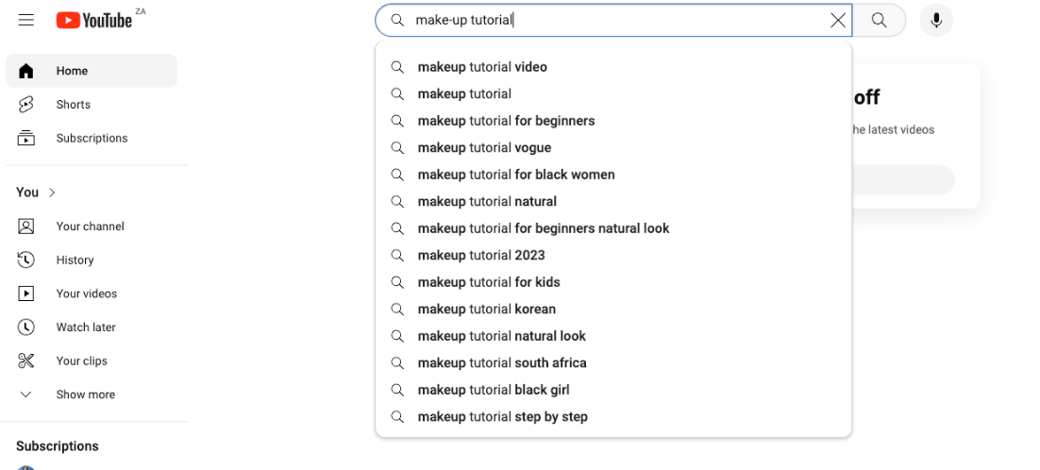

This process will also help you identify longtail keywords to target. Longtail keywords are (you guessed it) longer, more specific versions of a specific search term. While the search volume (the number of searches it gets) might be lower, the keyword difficulty (how many videos are currently competing for that keyword) will be lower, too.

As a result, it’s usually easier to rank for these keywords, and you’re in with a chance of hitting the broader keyword, too.

“I would suggest going with the longer tail version of that keyword so that you have a better chance of ranking for that term,” Jo says. “So, instead of focusing on trying to rank for the term ‘content audits’ or getting the search volume for this term only, I would suggest you try and rank for the longer tail terms. For example, ‘How to perform a content audit.’ Then, your video would explain to customers how to carry out a content audit. You are including the main topic but are also showing customers how to execute the content audit.”

### Google Trends (free)

Google Trends is a powerful free tool that will give you insights into what searchers were looking for over specific periods, as recently as the last 24 hours. Head to [trends.google.com](http://trends.google.com/), then click on the **Explore** tab.

Type your keywords into the search bar, and set your region, time period, and (optionally) category. Most importantly, be sure to click the dropdown menu under **Web Search**and change it to **YouTube Search**. Here’s a look at the results for “make-up tutorial”. Check out the **Related queries** box to help you find more keywords to target.

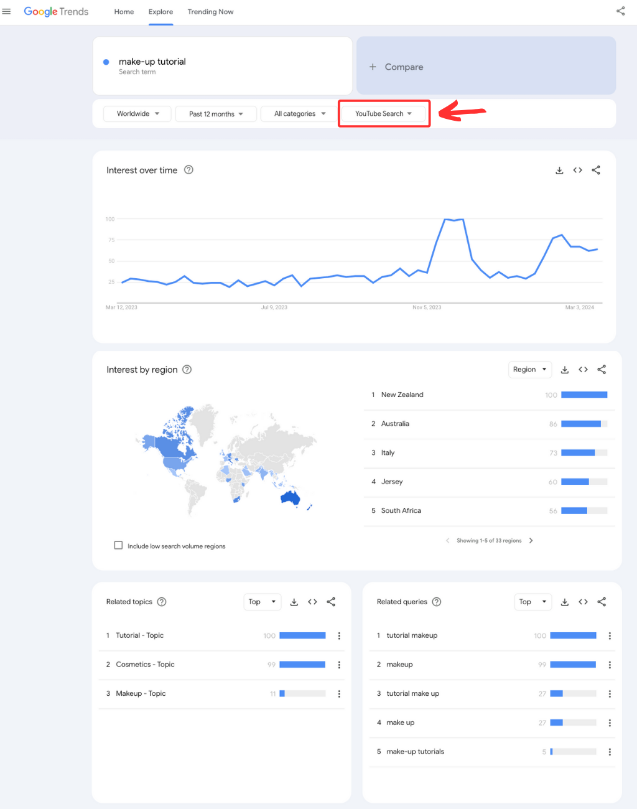

You can also use the **Trending Now**tab to check out all the trending searches in real-time or over the past 24 hours, so you can strike while the iron is hot on a particular topic.

### YouTube Studio

[YouTube Studio](https://buffer.com/social-media-terms/youtube-studio), the platform YouTubers use to upload their content, also has some pretty nifty keyword research tools baked in. To find them, head over to **YouTube Studio** > **Analytics** > **Research.**

Here, you’ll be able to see top searches that have led users to your existing content (more on this below), along with other videos currently performing well in your niche.

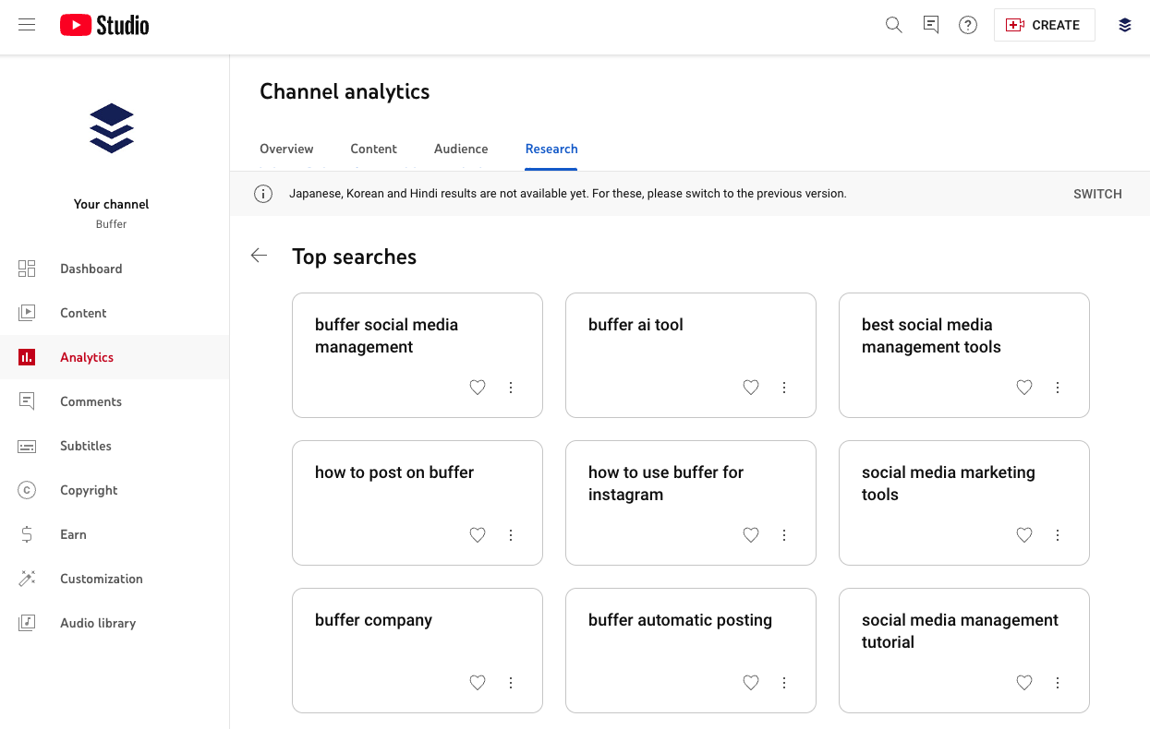

Ahrefs’ Keywords Explorer (paid)

Ahrefs is an SEO tool primarily built for web pages, but its Keywords Explorer will help you gather data specific to YouTube. The search volume metric is particularly helpful in that it will give you a number for search volume, allowing you to compare terms. While it doesn’t deliver the depth of data you’ll find via Semrush’s YouTube-specific tool (below), it’s a great option if you’re a marketer with a website to manage, too.

Ahrefs prices start at $99 per month.

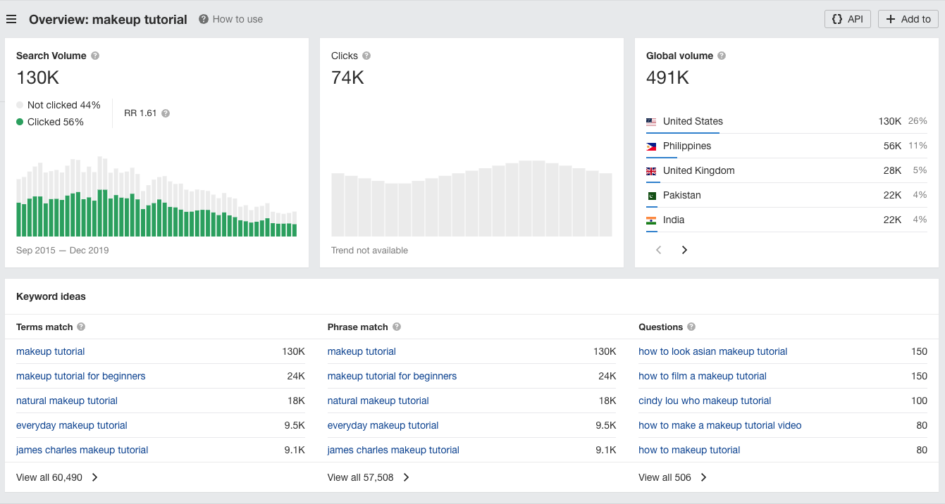

Semrush Keyword Analytics for YouTube (paid)

Semrush is an SEO research tool with its own handy YouTube keyword research product, a great standalone option for creators not interested in web page keyword research. It will help you pinpoint top keywords from specific time periods, fast-growing keywords, and most viewed videos.

You can also search for specific keywords to see the competitive rate, search volume, and related keywords.

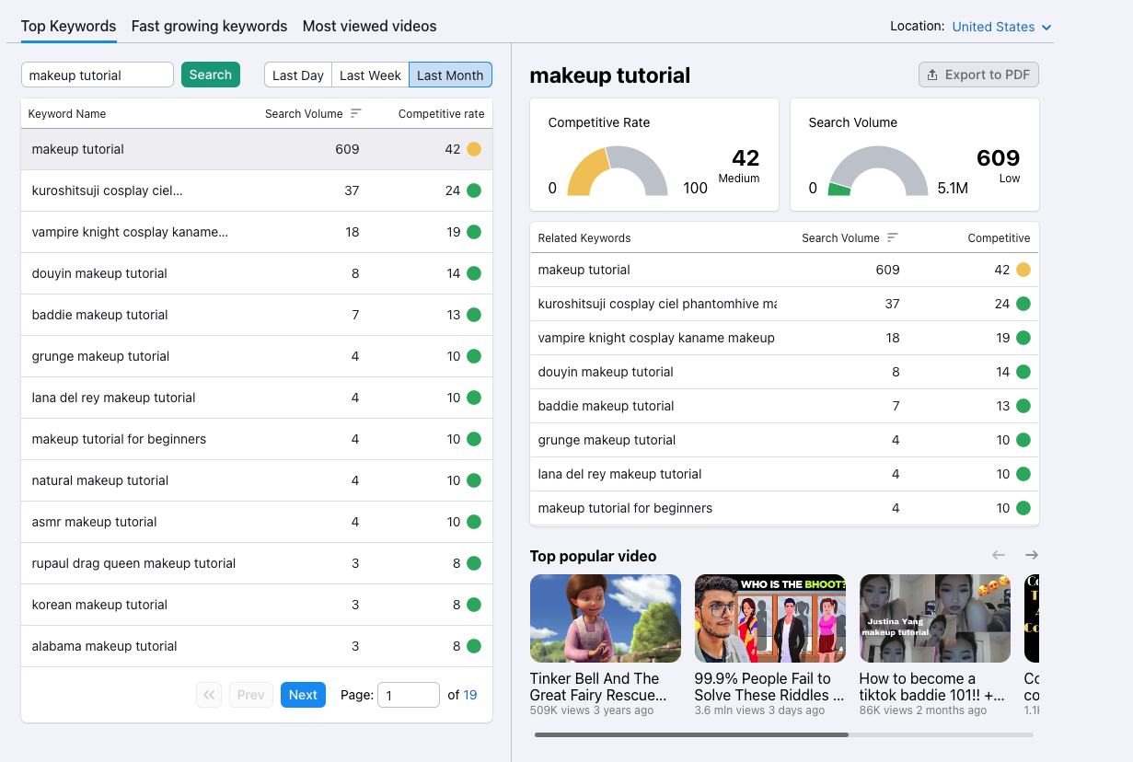

Semrush Keyword Analytics for YouTube prices start at $10 per month.

## 4. Choose your primary keyword

Your primary or target keyword is the number one term you’d like your video to rank for and the one you’ll focus on in the second part of this process, optimizing your video for search.

“I typically aim for one to three primary keywords per video,” [Sai Deshmukh](https://www.linkedin.com/in/seo-with-sai-deshmukh/), Director of Organic Growth (SEO, YouTube & Content Marketing) at Amber, told us. “I find that focusing on a few targeted keywords per video ensures that my content remains highly relevant to the audience's search queries.”

“For instance, if I'm creating a video about ‘Healthy Smoothie Recipes,’ I might select keywords like ‘easy smoothie recipes,’ ‘nutritious shakes,’ and ‘fruit smoothie ideas.’

[Get started now](https://login.buffer.com/signup?product=buffer&plan=free&cycle=year&cta=bufferBlogLibrary-post-midCTA-signup-1)

“Conversational tone keywords also increase the likelihood of my video ranking well in search results,” she adds.

So, how do you narrow it down? I’d argue the most important factor to consider when choosing your keywords is making sure your video delivers on the keyword promise.

“Creating a video should be hyper-specific to a need or want, for example, showcasing a product, or a how-to video, or a mini case study,” says Kelly, who has worked on optimizing videos on YouTube across verticals in several roles, from e-commerce to how-to videos.

“The core driving behavior on YouTube is the desire to find a quick solution or answer or dig into a topic, so trying to target too many keywords or cover too many topics in one video can be hard to rank as well as difficult to engage with as a viewer.”

However, it’s also important to consider how competitive the term is, along with search volume. This is where the tools above come in handy again.

For example, the term “makeup tutorial” is fairly competitive — there are millions of videos out on YouTube currently competing for this keyword. On the other hand, the more specific “natural makeup tutorial” boasts a lower competitive rate.

At a glance, it might seem like the latter is the best option. But — and this is where the nuance comes in — according to Semrush, only four people searched for “natural makeup tutorial” in the past month, while 609 people searched for “makeup tutorial.” Natural makeup tutorial will be far easier to rank for, but that doesn’t necessarily mean they will get as many views as the broader option, makeup tutorial.

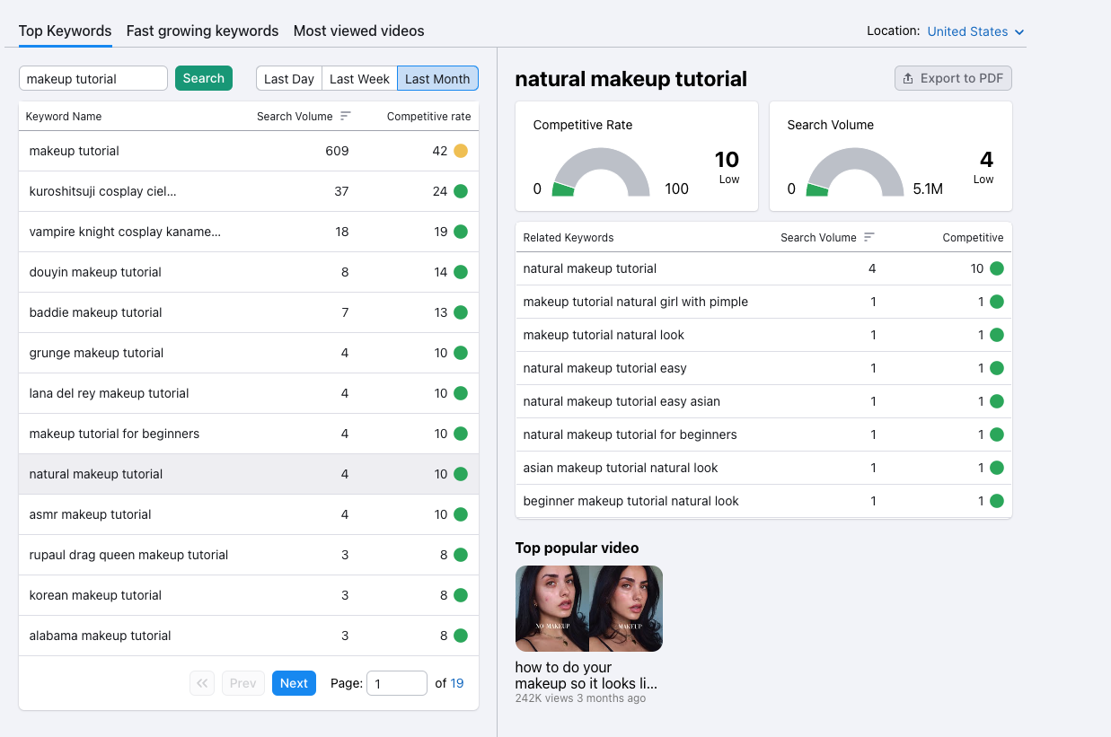

So, which is the best target keyword? There’s really no hard-and-fast rule — I’d recommend experimenting with both broad and niche terms and seeing which yields the best results for your channel.

For Gillian, at least, the search volume always outweighs the competition. “Yes, it can make it a little easier for you if you steer clear of the most competitive keywords, but you want to give a lot more weight to the popularity of the keyword,” [she says](https://www.youtube.com/watch?v=TjyqaRRLx_g&t=872s).

Got your keyword/s at the ready? That’s the tough part done. Now, onto the easy bit: optimization.

Optimizing your YouTube videos for search

With your video and keyword/s ready, it’s time to upload and optimize. The latter will happen

There are two main places you need to be sure to include your primary keyword, according to YouTube:

* Video title
* Video description

### How to optimize YouTube video titles

Your video title is one of the most important factors that will drive viewers to click on your video, so spend some time on this. Your video title should be simple, contain your target keyword, and the unique value you’re offering viewers.

Sai suggests using this as a starting point:

**[Primary keyword phrase] - [secondary keyword phrase] | [brand name]**

E.g.: How to Bake Chocolate Chip Cookies - Easy Recipe Tutorial | Sweet Delights

“This formula ensures that your primary keyword phrase is upfront, followed by a related secondary keyword phrase, and ending with your brand name for recognition,” Sai told us.

“Remember, balance is key,” she added. “Don't sacrifice readability and engagement for keyword stuffing! Your title should be clear, concise, and compelling to both viewers and search algorithms.

Here’s a great example from [Ale Jay](https://www.youtube.com/@AleJay):

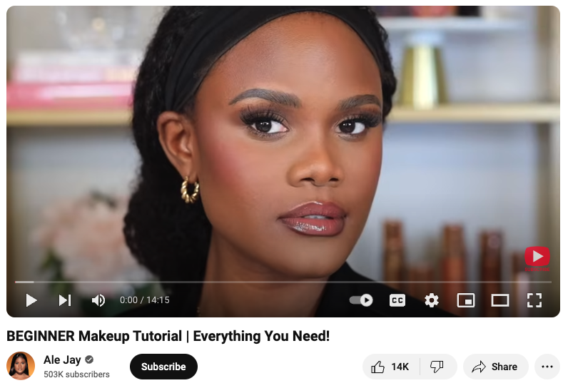

Her title is easy to grasp at first glance, emphasizes that the video is for makeup beginners, and comprehensive (“everything you need!”)

You have 100 characters to use for your video title, and the full title will appear in search results. Still, bear in mind that only the first 50 characters will be visible when your video appears in the related videos sidebar.

### How to optimize your YouTube video description

Your video description should offer a simple, easy-to-understand summary of what your video covers, featuring around two natural mentions of your primary keyword. If there’s a way to weave them in without sounding spammy, you can add in two or three related keywords here, too.

Let’s look at Ale’s again. In just two paragraphs, Ale manages to weave in subtle mentions of her target keyword, “makeup tutorial,” along with two related terms: “basic makeup” and “how to do makeup.” She also links to the specific products she used so viewers can mimic exactly what she does, another helpful step in improving user experience (and a way to [monetize her YouTube channel](https://buffer.com/resources/youtube-shorts-monetization/) with affiliate links).

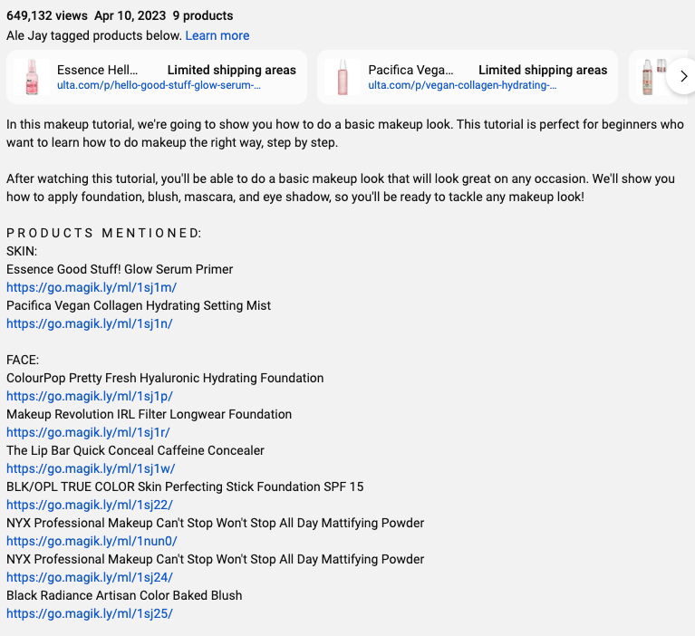

You have 5,000 characters to play with in your video description, but viewers will only see the first 115 - 135 characters in search results, depending on whether you have included video chapters or not.

How to add a video title and description

Adding your video title and description takes place during the upload process in [YouTube Studio](https://buffer.com/library/how-to-use-youtube-studio/).

1. Head over to YouTube Studio, click the **Create** button on the top right, and then **Upload videos.**
2. Drag and drop your video into the window, or choose **Select files** to open your device folders.
3. From here, click **Next** and follow the prompts to complete your video upload.

In the first window, you’ll find the fields to input those all-important **video titles** and **descriptions.**Here’s where you’ll set the brilliant title and description you worked on following the guidance above.

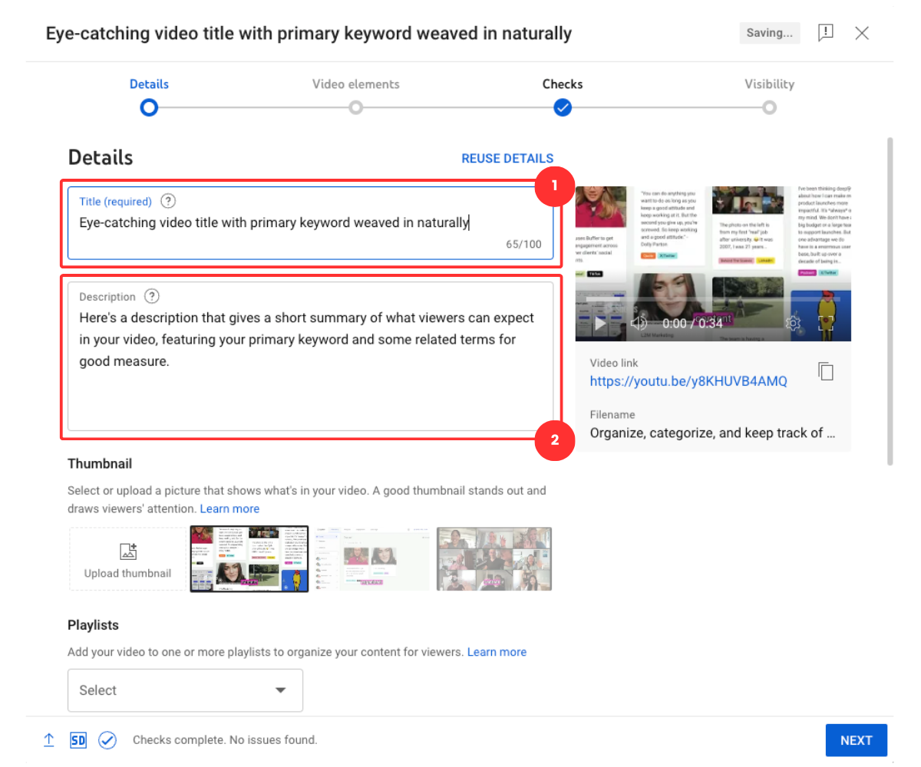

### Other YouTube SEO areas

While YouTube only pinpoints your video titles as areas crawled by their search engines, there is chatter among YouTubers and SEO experts that other areas may have an impact.

Among those are:

* **Video file name:**What you saved your video file as on your device.
* **Channel description:**How you’ve summarized your profile while creating your YouTube channel (editable via YouTube Studio).
* **Subtitles or closed captions:** YouTube can auto-generate captions, or you can upload your own SRT file (SubRip Subtitle, a plain text file) as part of the upload process.
* **YouTube**[**tags**](https://support.google.com/youtube/answer/146402?hl=en)**:**Keywords that can be added as part of the upload process by clicking ‘Show more’ in the Video Details section.
* **Playlists:**How you group and organize your videos on your channel.
* **Hashtags:** Hashtags added to the video description.

Sai is certain these will play a role in your video performance.

“YouTube goes beyond just titles and descriptions when it comes to ranking videos.

2024 is optimizing for user experience & relevance! I've found that using a mix of broad and niche tags is key,” she says.

It’s definitely worth including keywords in tags, channel description, and uploading your own SRT files, she adds. “While YouTube gives you plenty of space with 500 characters for tags, I've learned it's best to keep it focused and specific. In my experience, around five to twelve relevant tags do the trick! So, it's worth getting them right.

“My brand has also garnered good leads by using links in the channel descriptions. SRT file uploads have helped us with more engagement, too.”

## Analyzing your SEO performance

An often-skipped step in any [social media strategy](https://buffer.com/library/social-media-marketing-strategy/) is checking back in to see if your efforts are working. Luckily, YouTube has some great analytics tools that use two key metrics to make it really easy to measure the impact of your optimization.

To get to your analytics, go to **YouTube Studio**, then choose **Analytics** from the menu on the right. Here, you’ll be able to get a bird’s-eye view of your overall SEO performance, along with which terms your videos are ranking for.

To see the former, click on the **Content** tab on the top menu bar, then scroll down to the **How viewers find you** box. Take note of what percentage of traffic comes from YouTube search, then check back in again after optimizing your videos. At the top of the page, you can also segment this view by videos, Shorts, Lives, and posts.

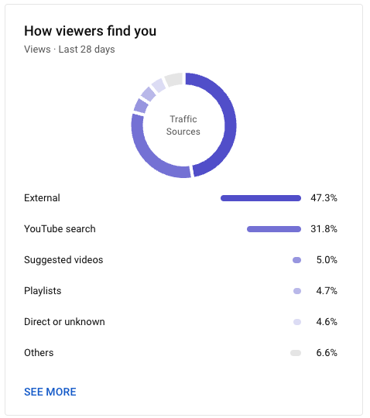

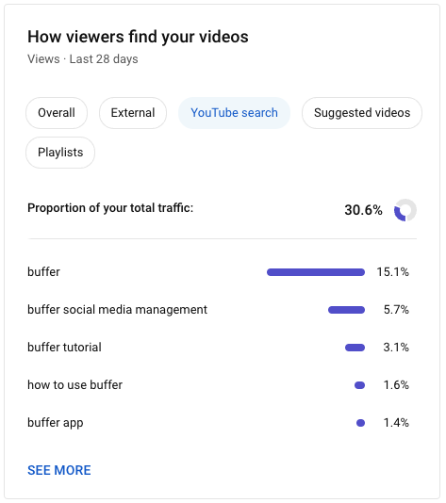

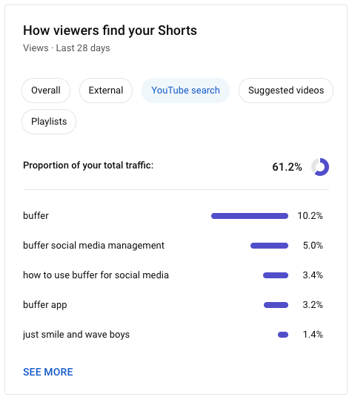

Clicking on **See more** will take you to a Google Analytics-style graph, where you can more closely monitor this traffic and changes over time.

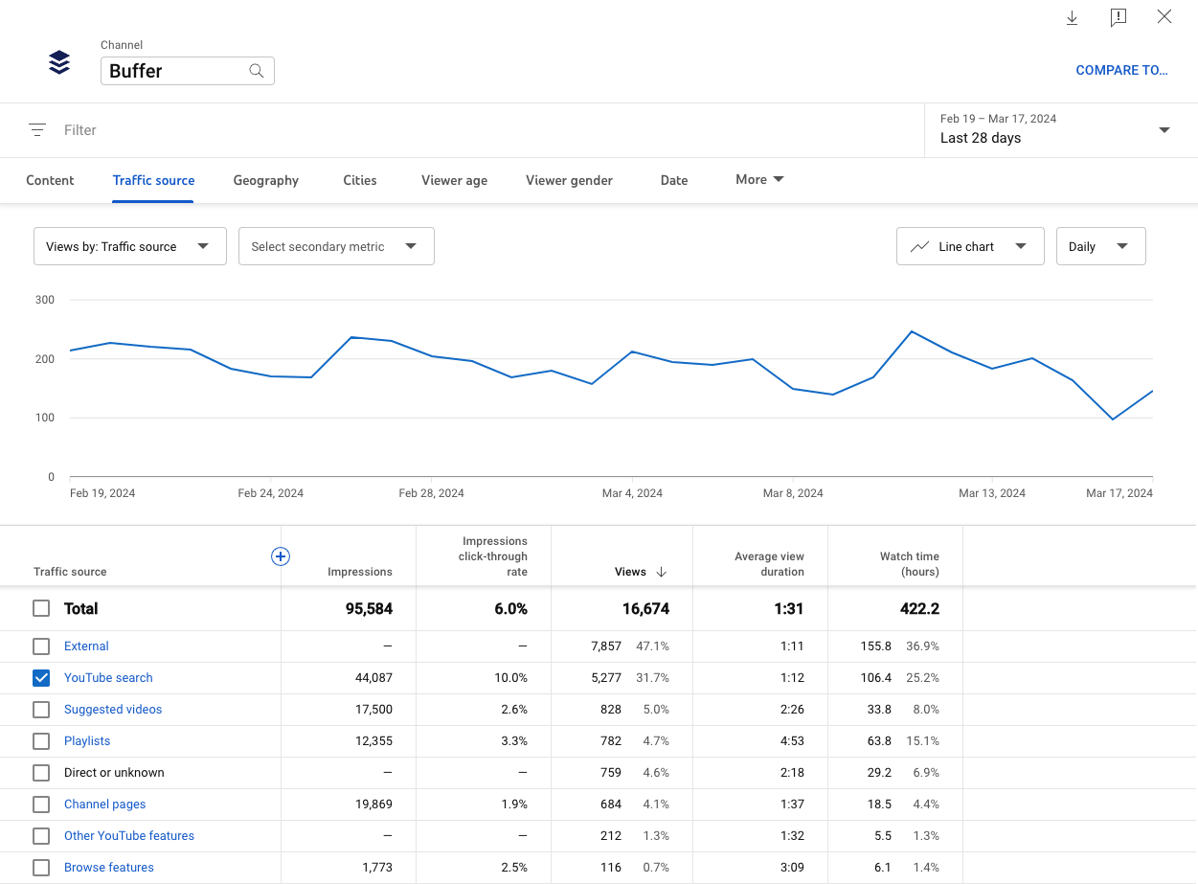

To get SEO results on specific videos — and see what your videos are ranking for — head back to the **Overview** page within **YouTube Studio** Analytics and scroll down to find the video you want to analyze. (If you can't find it here, you can also navigate to video-specific metrics via the Content tab on the left).

This will serve you a wealth of important metrics on your video, including watch time, key moments for retention, and engagement. To find out how well it performed in SERPs (search results), click on **Reach** in the menu at the top. Here, you’ll find a pie chart similar to the one above, this time showing how much traffic came to this particular video from search.

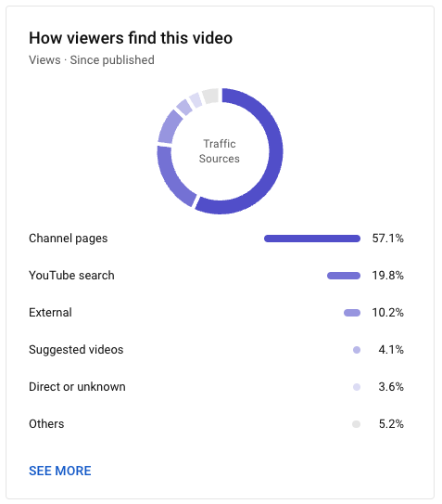

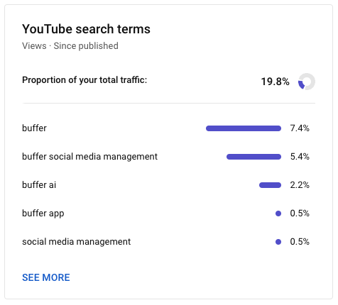

Scroll down again, and you’ll see the YouTube search terms box, where you’ll see exactly what keywords are bringing people to your video. Again, clicking **See more** will give you a more in-depth graph, which shows exactly how many people viewed your video from specific terms. How great is that?

## Experiment with YouTube SEO for the best results

As we often preach on this blog, what works for one target audience might not work for another – so your mileage with the above tips will vary! As always, the best course of action when it comes to optimizing your videos for search will be finetuning your process and tracking your performance.

How to Create Scroll-stopping YouTube Thumbnails (+ Tips from Top Creators)

## How to make YouTube thumbnails

## 1. Use the right image dimensions

There’s nothing that says, “I don’t know what I’m doing on YouTube,” like a pixelated, stretched, or black-bordered thumbnail — which is why starting with the right dimensions is the first step in thumbnail success.

**For full-length videos, the right YouTube thumbnail size is 1280 x 720 pixels.** That’s an aspect ratio of 16:9, which will display correctly on all devices.

You can upload a file with a minimum width of 640 pixels, but it’s wise to stick to the 1280 x 720 dimensions so your thumbnail image displays perfectly.

JPG, [GIF](https://buffer.com/library/animated-gifs/), and PNG files will work, but you’ll get a better-quality image with the latter option.

Here’s an example of the image dimensions for YouTube videos:

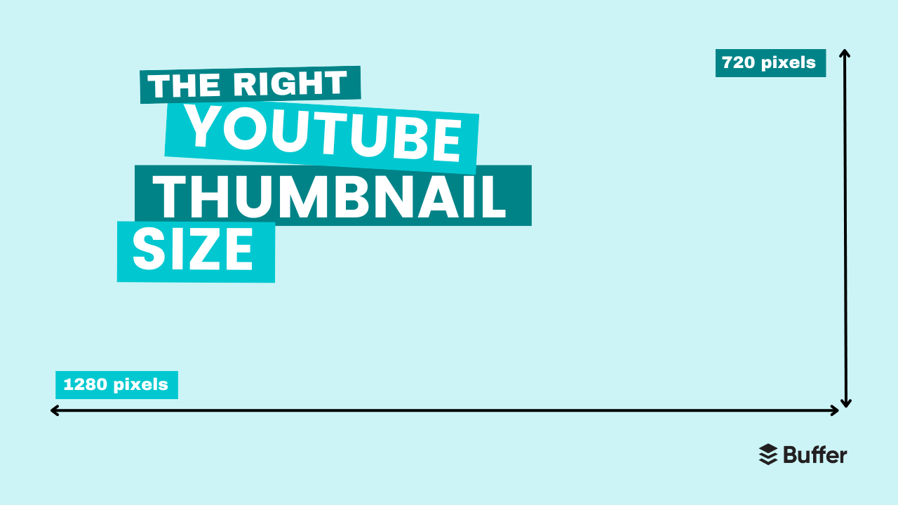

## 2. Opt for bold, bright colors

Paul believes high contrast elements are one of the keys to thumbnail success. “Bold, bright colors help your thumbnail stand out in a sea of videos,” he says. “I have a set of templates that I leverage that make the logo and text blocks really pop out.”

This is something the study I mentioned earlier found, too. Of the 740 most-watched videos they analyzed, 88 percent of thumbnails were vibrant and colorful.

This is one of the biggest changes Alicja made in her thumbnail design, and it’s certainly impacted views. Here’s a comparison of one of her earlier videos featuring her initial design to the newer one on the right.

While plenty of factors are at play here, it’s worth noting that the new thumbnail version has ten times the views of the older one on the left despite being uploaded more recently.

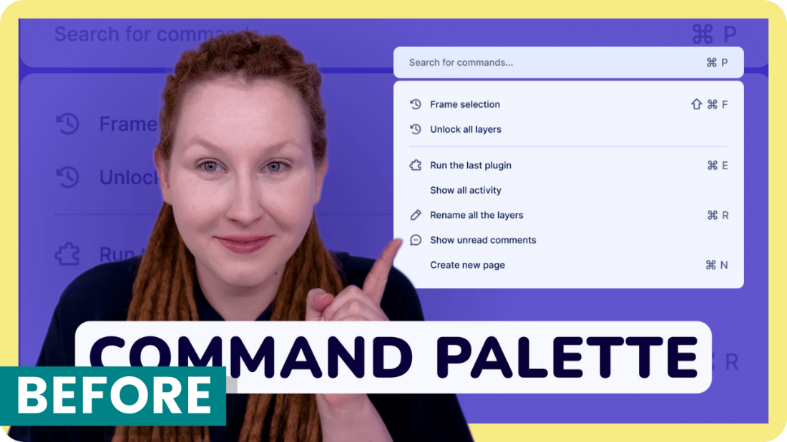



## 3. Feature a face showing emotion

Using an excited, shocked, or sad face is a favorite device of YouTubers the world over — and with good reason. According to the thumbnails study, 72 percent of the most popular videos on YouTube in 2020 “featured an image of a human, averaging 921,000 more views than those without a human face.”

Alicja notes that, if using an image of yourself or a guest, the picture should be a still from the video or a photo taken simultaneously. “Make sure you’re wearing the same clothes and hairstyle,” she says. “Otherwise, it will feel staged.”

She adds, “I think that showing emotions on your thumbnail, being shocked, happy, or sad, also catches the viewer’s attention.”

The data supports her feelings — visible emotion was another pattern that emerged in the thumbnail study. [Researchers found](https://www.bestseocompanies.com/blog/youtube-thumbnails/) that a display of certain feelings was another common feature in these top-performing videos. Content conveying sadness had the highest average view count (2.3 million), followed by joy and humor (1.5 million), then anger or fear (818,000).

What’s interesting to note here is that the research didn’t technically specify the emotion needs to be on a human face. Their findings, mentioned separately from the point on thumbnails featuring faces, were framed as “content conveying the emotion of…” — a loophole that Paul has taken advantage of.

Brought to you by

### Try Buffer for free

140,000+ small businesses like yours use Buffer to build their brand on social media every month

[Get started now](https://login.buffer.com/signup?product=buffer&plan=free&cycle=year&cta=bufferBlogLibrary-post-midCTA-signup-1)

Given that Paul’s videos are primarily screen recordings and voice-overs, he has chosen not to use his actual face on his thumbnails. He uses versions of his Apple Memoji (an emoji-like avatar of his face that you can create on iPhone and other tools). The avatars definitely convey emotion (and Paul’s viewership speaks for itself!).

"I used a Memoji for my channel profile photo originally — no real reason as to why — and kind of just decided to stick with that aesthetic," Paul says. "But it definitely does ease the work required from me as I have preset facial expressions already available to me that I can just rely on. And in a way, it's now something that people recognize in my thumbnails, too."

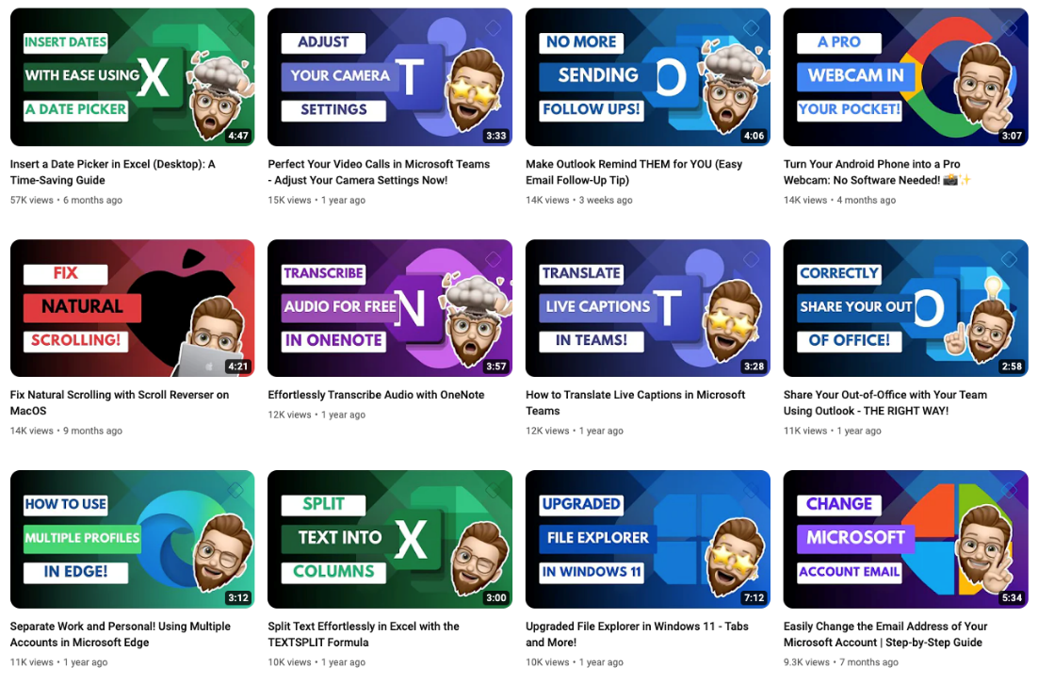

## 4. Include short, snappy text

Another attention-grabbing detail both Alicja and Paul swear by? Text.

While video titles are an immensely important factor in the [YouTube algorithm](https://buffer.com/resources/youtube-algorithm/), they may get lost in the scroll.

Viewers’ eyes are more likely to be drawn to the much larger, more colorful graphics on thumbnails — which is why it can be helpful to give them a little extra context about your video with some well-chosen words.

“A few words that pique curiosity and give viewers a reason to click,” Paul says. “Ideally, I try to keep this to six words or less but still interest the audience. More than that tends to result in a font that is too small to read easily.”

It’s worth stressing that keeping it simple is key — it’s one of MrBeast’s team’s main focus areas when mocking up thumbnails, Chucky Appleby, from MrBeast’s creative team, said in a [recent interview](https://www.youtube.com/watch?v=HP-rqigfw2s&t=380s&ab_channel=CreatorInsider).

“Make your thumbnail easy to understand so that when people look at it the first time, they’re saying, “I know what’s going on in this video, so I’m going to click on it.”

“If they have to spend 10 or 20 seconds to try to understand what’s going on in your thumbnail, they’re probably not going to be that invested, and they’re going to keep scrolling.”

## 5. Create a template for consistency

A recognizable brand is your best friend when making sure your content stands out from the crowd. A cohesive channel shows professionalism — a subtle signal to your audience that they can trust you and the content you produce.

It also encourages them to subscribe to your channel if they discover another of your videos and recognize the branding. To that end, I’d recommend creating a lightweight brand kit: a color palette, font, and graphic style that you use consistently across both your full-length videos and YouTube Shorts.

To make this process simple, it’s worth setting up a thumbnail template in your image editing tool of choice — software like Canva, Figma, Visme, and Adobe Photoshop make this really easy to do and are a must-try for YouTube thumbnail design.

In your thumbnail template, consider these design elements:

* **Dimensions:** 1280 x 720 pixels for full-length videos.
* **Fonts:** Choose at least one easy-to-read font (or go the extra mile with a font pairing — search “font pairing” in Pinterest for fonts that go well together).
* **Color:** Select a palette of cohesive colors (Pinterest can help here, too — search for “color palette.”)

Protip: While you can create a custom YouTube thumbnail template from scratch, design tools like Canva and Visme will have customizable YouTube thumbnail templates ready for you to tweak and make your own. Consider them your very own YouTube thumbnail makers.

### How to add a thumbnail to your YouTube videos

Uploading a thumbnail to accompany your video is pretty simple. All you need to do is follow the upload process in [YouTube Studio](https://buffer.com/library/how-to-use-youtube-studio/), the accompanying YouTube platform where creators can manage and upload their content. Here’s a quick step-by-step tutorial:

1. Make sure you’re logged into your YouTube account, then head over to [studio.youtube.com](http://studio.youtube.com).
2. Hit the **Create** button on the top right.
3. Drag and drop your video file into the window, or click **Select file** to open your device folders.
4. Here, you’ll be able to add your video title, description, playlist, and other important video information. It’s also where you’ll find the option to add a thumbnail right underneath the description text box. Click **Upload thumbnail** and choose the file you want to use.
5. Click **Next** and, if needed, add additional video elements like subtitles, an end screen, or cards.
6. Click **Next** again. On the Checks screen, you’ll see whether YouTube has cleared your video for use (found no copyright violations).
7. Click **Next** and choose your visibility settings.
8. Hit **Publish.**

## 5 YouTube thumbnail examples

Looking for inspiration? Here are some great examples of some of the best YouTube thumbnails I’ve come across. They’re eye-catching yet cohesive — and the proof of their success is in those stellar viewership numbers.

### Ali Abdaal

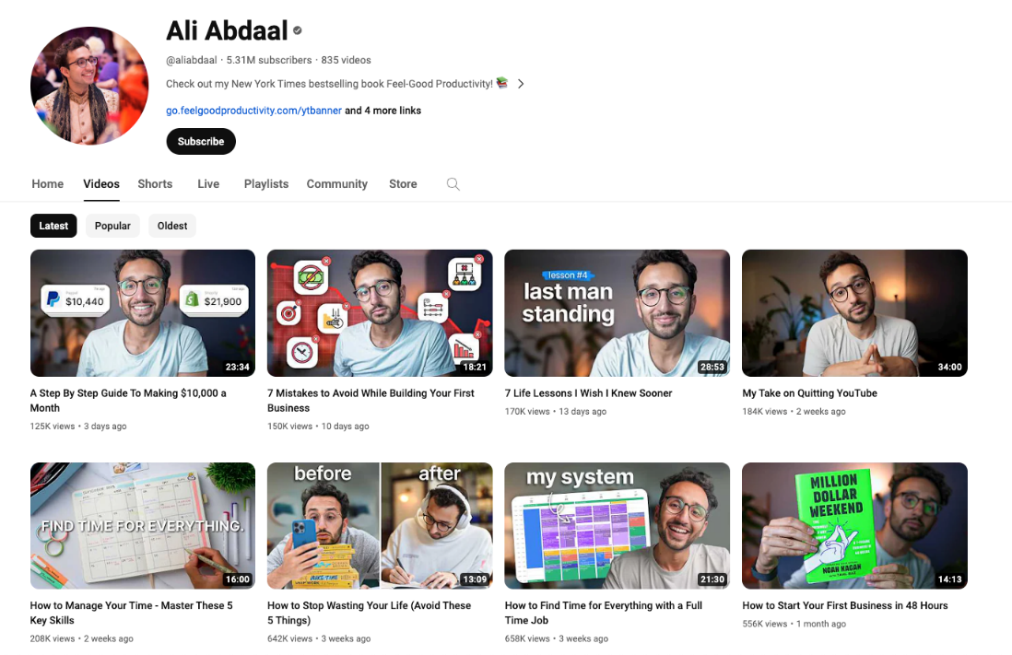

One of my favorite YouTubers, [Ali Abdaal](https://www.youtube.com/@aliabdaal), opts for a clean, professional aesthetic that will appear to his audience of students, aspiring entrepreneurs, and productivity nerds.

Notice how well-let his high-quality photos are, which makes them pop ahead of the more muted backdrops.

### Call Her Daddy

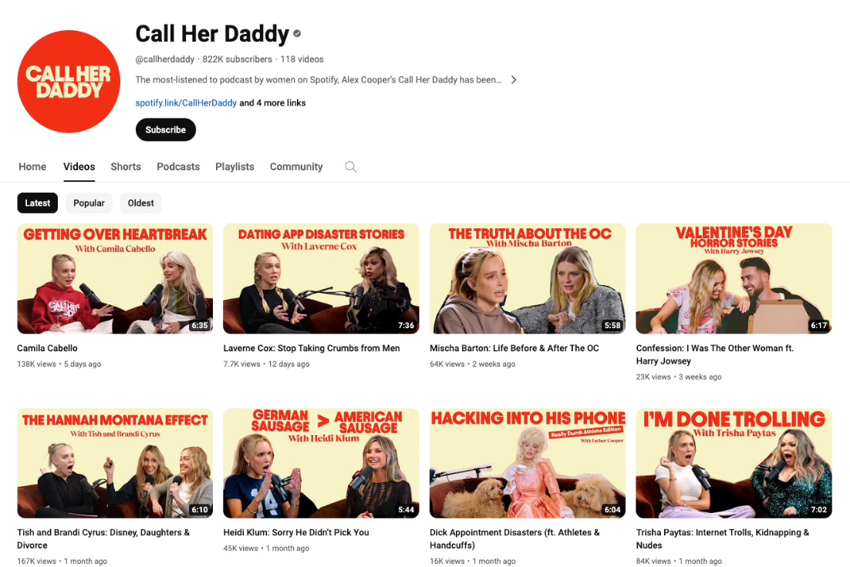

The YouTube channel for the hit podcast [Call Her Daddy](https://www.youtube.com/@callherdaddy/videos) features a straightforward approach: two fonts, two colors, and an emotive still from the podcast recording of host Alex Cooper and her guests.

What’s interesting, though, is how Alex (or, rather, her team) subtly edits the podcast title to make the thumbnail version even more intriguing and offer a peek at what juicy details viewers can expect the guest to discuss.

### HealthNut Nutrition

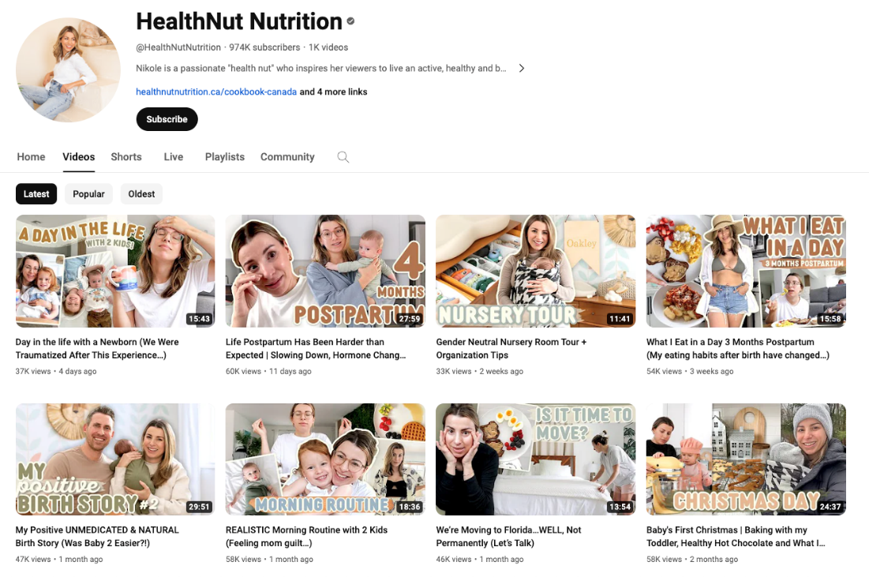

Food and lifestyle blogger Nikole Goncalves (aka [HealthNut](https://www.youtube.com/@HealthNutNutrition/videos)) has clear brand colors and fonts she sticks to in every thumbnail — an aesthetic that carries across her other social media accounts, too, which is a nice touch.

### Asia Jackson

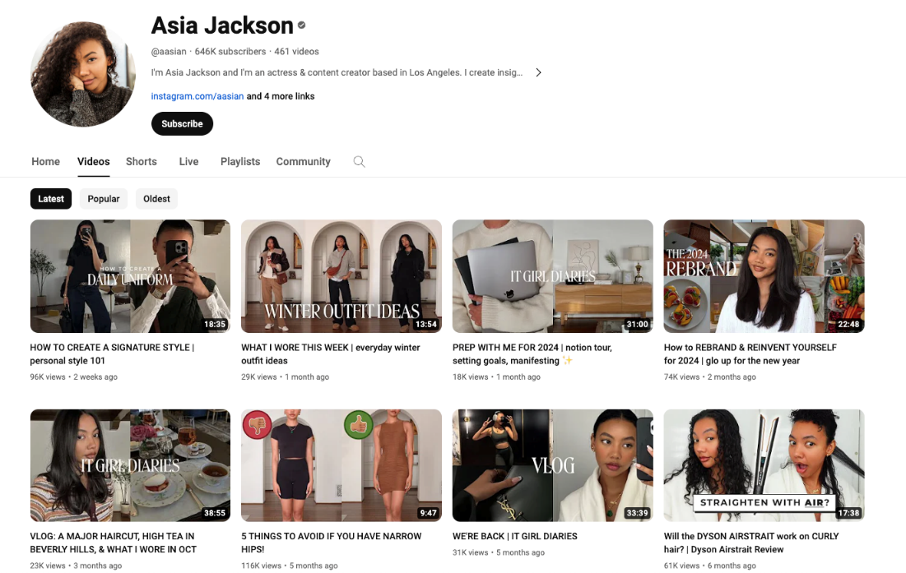

[Asia Jackson](https://www.youtube.com/@aasian/videos) is a great example of knowing your target audience and how their preferences might impact the thumbnail best practices I’ve laid out above. She’s got a clear, consistent design style with clever on-thumbnail titles and the occasional emotive photo of her face.

However, the tones are muted (no bright, vibrant colors), and her designs focus on the aesthetics within her content (her outfits, decor, and daily life). She knows her subscribers come to her to emulate her style, and she puts that front and center with every thumbnail she creates.

### MrBeast

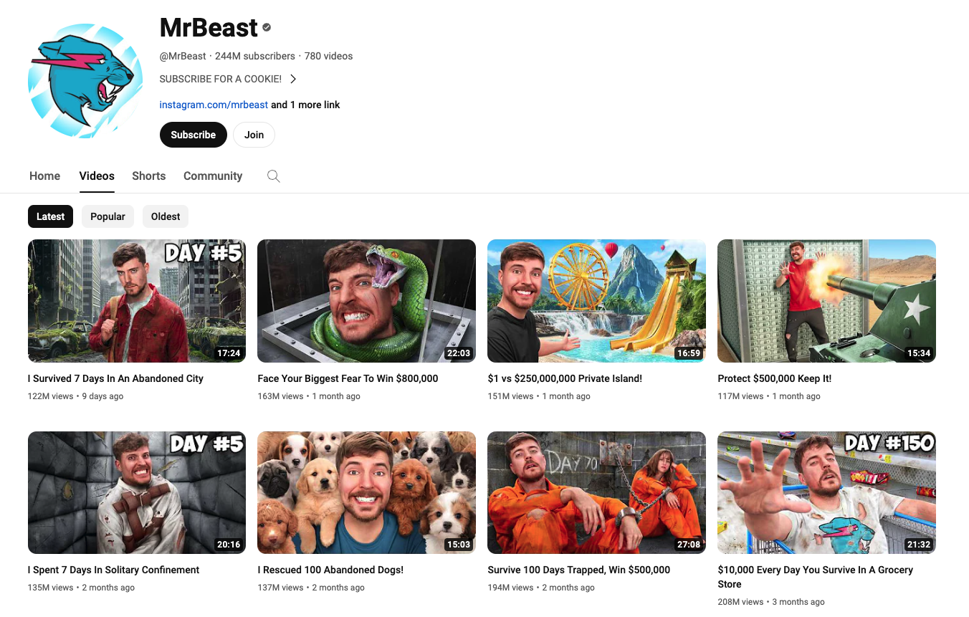

What YouTube thumbnail advice article would be complete without mention of YouTube’s reigning creator, [MrBeast](https://www.youtube.com/@MrBeast/videos)? Notice how the YouTuber’s design team keeps every image eye-catching but easy to understand at a glance.

Chucky shared that the use of MrBeast’s (aka Jimmy Donaldson’s) face is also an intentional way to build trust with viewers. “In 2019 we decided to start putting Jimmy’s face in every thumbnail because we were branding the videos around him.”

“If you trusted Jimmy on the last video that he uploaded, and he delivered on the content, then the next video you see his face, and you’d be like, ‘Oh, that’s the guy that delivered on the last video I enjoyed so I’m going to click on this video as well.”